A10 Proof of Concept Test Plan

Customer: *Buying A10*

Date Performed:

A10 Engineer:

Donkey Kong, [dkong@a10networks.com](mailto:dkong@a10networks.com), 111-111-1111

Partner:

Rock Solid Partner, Inc.

Partner Engineer(s):

Patty Partner, [ppartner@rsp.com](mailto:ppartner@rsp.com), 987-654-3210

Customer Engineers:

Captain Customer, customers@buyingA10.com, 123-456-7890

**Table of Contents**

I. Proof of Concept Goals 3

II. Preliminary Information 3

A. Services 3

III. Steps 4

IV. Goals 4

V. Results 4

VI. Appendix 5

A. FlexPool – Website 5

1. Raise allocated bandwidth to 300Mbps 8

2. Decrease allocated bandwidth to 100Mbps 10

B. FlexPool – AxAPI Commands 12

C. Postman Screenshots of glm AxAPI calls. 13

# Proof of Concept Goals

A proof of concept is defined as, *‘the stage during the development of a product when it is established that the product will function as intended’*[1]To that end, the proof of concept goals should be to test a sampling of the services that are required to ensure the A10 ADC will meet all requirements of the customer. Full implementation of all services and/or requirements can be supported through A10 Professional Services.

Typical goals are to ensure the high-availability of a load-balanced application(s), through a single location or global server load-balancing for servers located in multiple locations.

Any critical applications (i.e. Exchange/Sharepoint) should also be configured and verified.

Other features, such as WAF or AAM may require more complex configuration. Should those features be required, discussions should be included on the exact usage & test/pass criteria to be meet during the PoC.

The specific goal(s) to be met by the proof of concept should be identified in the kick-off meeting.

# Kick-Off Meeting

The purpose of the kick-off meeting is to discuss customer needs and identify how the A10 ADC can prove to meet those goals. For each application/feature tested, the test along with it’s pass criteria should be determined.

## Agenda

### Architecture to be achieved. (eg. one-armed, routed inline, transparent, etc.)

The PoC

Other items to identify:

SSL requirements: certificates/keys

# Timeline

# Preliminary Information

## Services

Server Load-Balancing (SLB)

Applications

Web services (IIS, Apache, etc)

Exchange

Sharepoint

Lync

Other: ________________________

Other: ________________________

Other: ________________________

Other: ________________________

Information required:

* Complete A10_PoC_Data spreadsheet
* Use ACT for Exchange, Sharepoint, Lync

Global Server Load-Balancing (SLB)

Applications

Web services (IIS, Apache, etc)

Exchange

Information required:

* Domain:
* Sub-delegated domain:

Application Access Management (AAM)

Form-Based Access

Windows Integrated Authentication

Other: ________________________

Information required:

* AD/LDAP server

# Steps

# Goals

# Results

# Appendix

## FlexPool – Website



### Initial allocated bandwidth to 200Mbps

vThunder05-Active-vMaster[4/1](config:1)#show run glm

!Section configuration: 94 bytes

!

glm use-mgmt-port

glm enable-requests

glm token vThdXXXXXXXX

!

vThunder05-Active-vMaster[4/1](config:1)#glm send license-request

BASE License successfully updated, please log out and log back in to access license features.

!

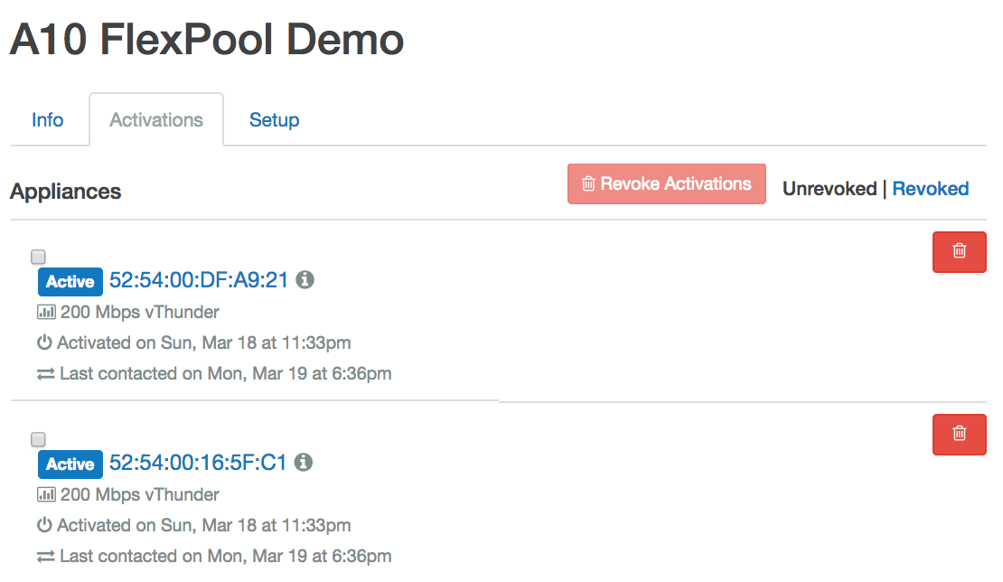

vThunder05-Active-affinity-def-vMaster[4/1](config:1)#glm send license-request

BASE License successfully updated, please log out and log back in to access license features The license cannot allocate 200 Mbps. It is outside the bandwidth boundaries set on the license in the GLM. Those boundaries are 2 Mbps minimum and 6 Mbps maximum.

vThunder05-Active-affinity-def-vMaster[4/1](config:1)#show license-info

Host ID : 1DA6DE06D170F85F643EFD648E24BF7329165AFF

USB ID : Not Available

Billing Serials:

Token :

Product : CFW

Platform : vThunder

GLM Ping Interval In Hours : 24

------------------------------------------------------------------------------------

Enabled Licenses Expiry Date (UTC) Notes

------------------------------------------------------------------------------------

SLB None

CGN None

GSLB None

RC None

DAF None

WAF None

SSLI 07-July-2018

DCFW 07-July-2018

GIFW 07-July-2018

URLF 07-July-2018

IPSEC 07-July-2018

AAM None

FP None

WEBROOT N/A Requires an additional Webroot license.

THREATSTOP N/A Requires an additional ThreatSTOP license.

QOSMOS N/A Requires an additional QOSMOS license.

WEBROOT_TI N/A Requires an additional Webroot Threat Intel license.

CYLANCE N/A Requires an additional Cylance license.

200 Mbps Bandwidth 07-July-2018

### Raise allocated bandwidth to 300Mbps

vThunder05-Active-affinity-def-vMaster[4/1](config:1)#glm allocate-bandwidth 300

vThunder05-Active-vMaster[4/1](config:1)#show run glm

!Section configuration: 94 bytes

!

glm use-mgmt-port

glm enable-requests

glm allocate-bandwidth 300

glm token vThdXXXXXXXX

!

vThunder05-Active-vMaster[4/1](config:1)#glm send license-request

BASE License successfully updated, please log out and log back in to access license features.

!

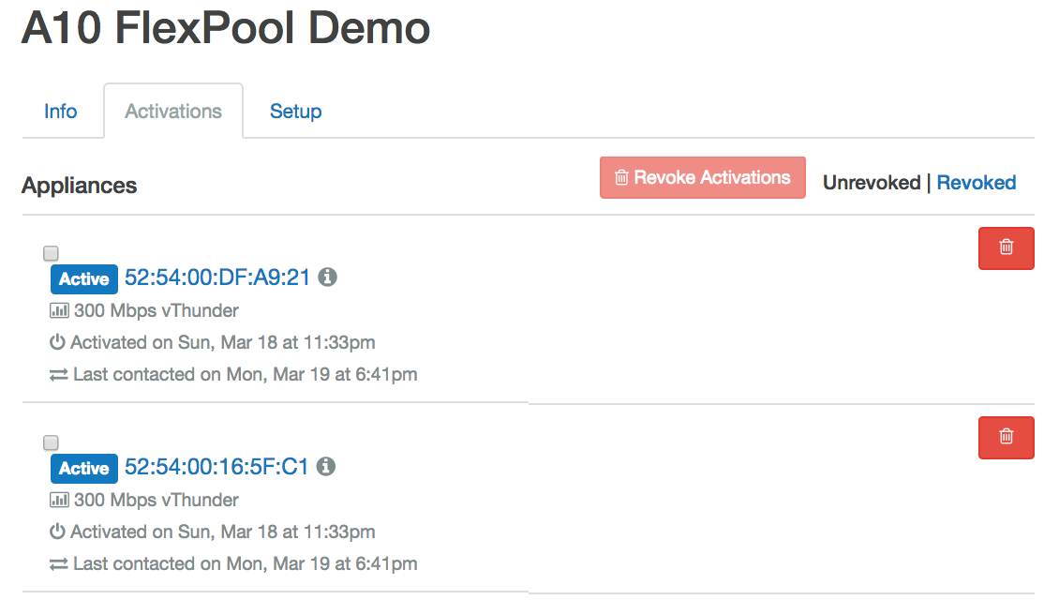

vThunder05-Active-vMaster[4/1]#show license-info

Host ID : 1DA6DE06D170F85F643EFD648E24BF7329165AFF

USB ID : Not Available

Billing Serials:

Token :

Product : CFW

Platform : vThunder

GLM Ping Interval In Hours : 24

------------------------------------------------------------------------------------

Enabled Licenses Expiry Date (UTC) Notes

------------------------------------------------------------------------------------

SLB None

CGN None

GSLB None

RC None

DAF None

WAF None

SSLI 07-July-2018

DCFW 07-July-2018

GIFW 07-July-2018

URLF 07-July-2018

IPSEC 07-July-2018

AAM None

FP None

WEBROOT N/A Requires an additional Webroot license.

THREATSTOP N/A Requires an additional ThreatSTOP license.

QOSMOS N/A Requires an additional QOSMOS license.

WEBROOT_TI N/A Requires an additional Webroot Threat Intel license.

CYLANCE N/A Requires an additional Cylance license.

300 Mbps Bandwidth 07-July-2018

### Decrease allocated bandwidth to 100Mbps

vThunder05-Active-affinity-def-vMaster[4/1](config:1)#glm allocate-bandwidth 100

vThunder05-Active-vMaster[4/1](config:1)#show run glm

!Section configuration: 94 bytes

!

glm use-mgmt-port

glm enable-requests

glm allocate-bandwidth 100

glm token vThd10516000

!

vThunder05-Active-vMaster[4/1](config:1)#glm send license-request

BASE License successfully updated, please log out and log back in to access license features.

!

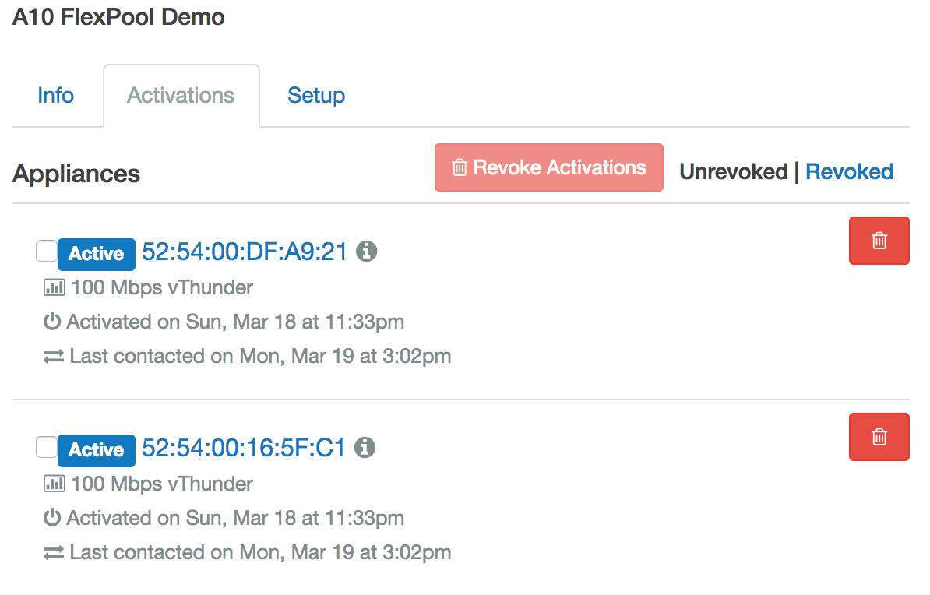

vThunder05-Active-vMaster[4/1]#show license-info

Host ID : 1DA6DE06D170F85F643EFD648E24BF7329165AFF

USB ID : Not Available

Billing Serials:

Token :

Product : CFW

Platform : vThunder

GLM Ping Interval In Hours : 24

------------------------------------------------------------------------------------

Enabled Licenses Expiry Date (UTC) Notes

------------------------------------------------------------------------------------

SLB None

CGN None

GSLB None

RC None

DAF None

WAF None

SSLI 07-July-2018

DCFW 07-July-2018

GIFW 07-July-2018

URLF 07-July-2018

IPSEC 07-July-2018

AAM None

FP None

WEBROOT N/A Requires an additional Webroot license.

THREATSTOP N/A Requires an additional ThreatSTOP license.

QOSMOS N/A Requires an additional QOSMOS license.

WEBROOT_TI N/A Requires an additional Webroot Threat Intel license.

CYLANCE N/A Requires an additional Cylance license.

100 Mbps Bandwidth 07-July-2018

## FlexPool – GLM AxAPI Commands

### AxAPI to configure FlexPool (glm) commands:

curl -X POST \

https://192.168.0.51/axapi/v3/glm \

-H 'authorization: A10 6115f7ad0a575ed2aa5d9a683199c8' \

-H 'content-type: application/json' \

-d '{

"glm": {

"use-mgmt-port": 1,

"enable-requests": 1,

"allocate-bandwidth": 4,

"token": "A10111111111"

}

}'

### AxAPI to send FlexPool license request immediately:

curl -X POST \

https://192.168.0.51/axapi/v3/glm/send/ \

-H 'authorization: A10 618b193bb13c988ba5ef06f4640e5a' \

-H 'content-type: application/json' \

-d '{

"send": {

"license-request": 1

}

}'

## Postman Screenshots of GLM AxAPI calls.

### Set the body as shown.



### Set the body as shown.



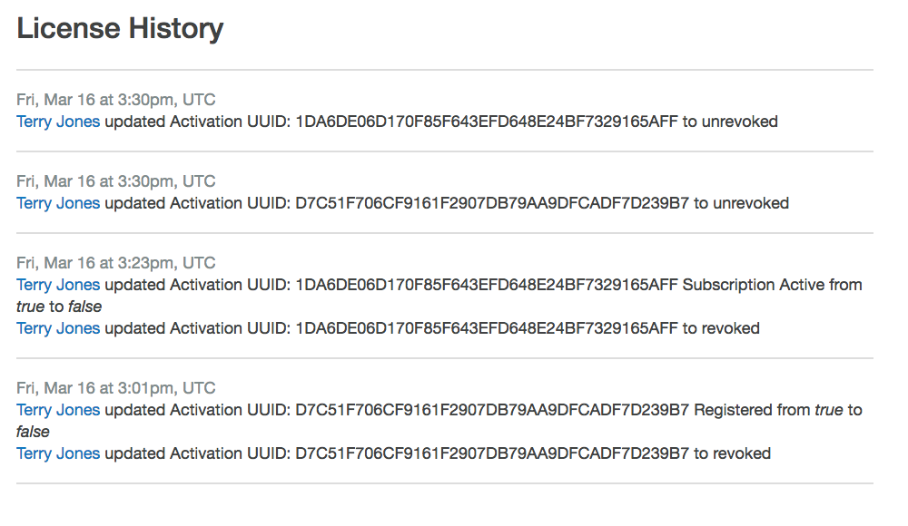

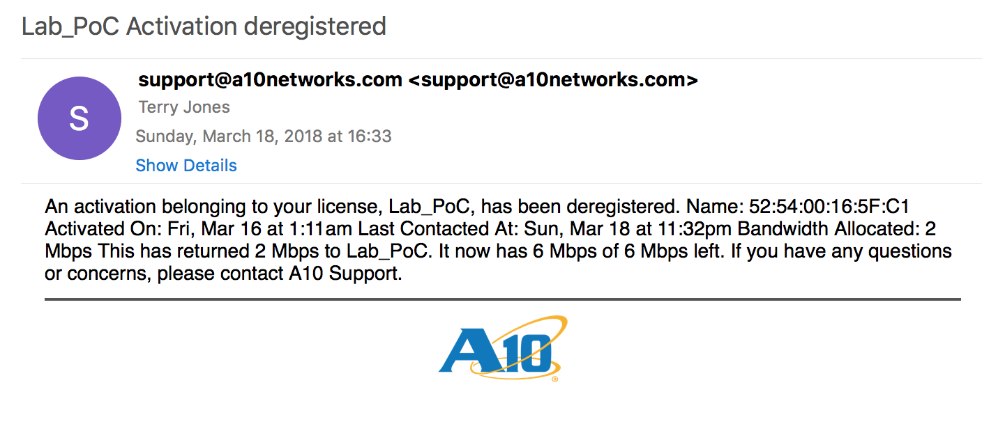

# Artifacts

## Kick-Off Meeting Notes:

Date: .

Attendees:

|  |  |  |  |
| --- | --- | --- | --- |
| Name | Position | Phone | Email |
|  |  |  |  |
|  |  |  |  |
|  |  |  |  |
|  |  |  |  |
|  |  |  |  |

NOTES:

|  |
| --- |
|  |
|  |
|  |
|  |
|  |
|  |
|  |
|  |
|  |
|  |
|  |
|  |
|  |
|  |
|  |
|  |
|  |
|  |
|  |
|  |
|  |
|  |
|  |
|  |
|  |
|  |
|  |
|  |
|  |
|  |
|  |
|  |
|  |
|  |

1. Collins English Dictionary. Copyright ¬© HarperCollins Publishers